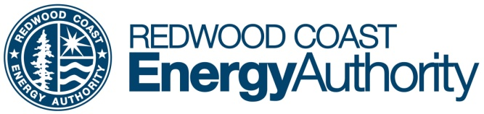
633 3rd Street Eureka, CA 95501
Phone (707) 269-1700 Fax (707) 269-1777
www.redwoodenergy.org

Contact: Nancy Stephenson
Phone: c: (707) 382-7110
Email: nstephenson@RedwoodEnergy.org
PRESS RELEASE – FOR IMMEDIATE RELEASE

Renewable and Doable
The Redwood Coast Energy Authority hosts two panel discussions featuring state and local energy leaders
EUREKA, CA, October 12 – In recognition of energy month and in response to public concerns about recent local and state energy issues, the Redwood Coast Energy Authority (RCEA) will be hosting two evening panel discussions in October. Session one, with state representatives, will take place on October 20. Session two, featuring Humboldt County projects, programs, and leaders, will be on October 27. Both take place via zoom, online, from 5:30-7:00 pm.
The transition to increased use of renewable energy has progressed greatly in recent years, but at the same time we are seeing rapid changes to our climate and new challenges to our energy distribution systems. How are these phenomena connected? What are the causes of the rolling blackouts and PSPS events, and what does the future of energy look like? What is the role of RCEA and community choice energy programs in all of this? How will RCEA’s renewable energy projects and strategic planning help Humboldt County become more resilient and stable as the state of California phases out its aging gas infrastructure and nuclear power plants?
Guest panelists for session one, “Renewable and Doable: California Rises to the Clean Energy Challenge,” on Tuesday, October 20, will include some of our state’s top authorities. Karen Douglas, Commissioner, California Energy Commission; Beth Vaughan, Executive Director of the California Community Choice Association; and Matthew Marshall, Executive Director of RCEA.
Session two on Tuesday, October 27, “Energy Reliability, Resilience and Innovation in Humboldt County,” will feature Jana Ganion, Sustainability and Government Affairs Director at the Blue Lake Rancheria; Jon Fortune, Senior Director at Swell Energy; Jim Zoellick, Principal Engineer with the Schatz Energy Research Center, and Richard Engel, Director of Power Resources at RCEA.
Brief panelist presentations will allow for ample time for discussion and we encourage questions from the public during each 90-minute event. RCEA staff Mahayla Slackerelli, Account Services Manager, and Jocelyn Gwynn, Power Resources Manager, will moderate.
More information and registration details can be found on RCEA’s website. www.RedwoodEnergy.org/events; email Nancy Stephenson at nstephenson@RedwoodEnergy.org, or call (707) 382-7110.

ABOUT RCEA:
The Redwood Coast Energy Authority is a local government joint powers agency whose members include the County of Humboldt, all local cities, and the Humboldt Bay Municipal Water District. The Energy Authority's purpose is to develop and implement sustainable energy initiatives that reduce energy demand, increase energy efficiency, and advance the use of clean, efficient, and renewable resources available in the region.

