Biomass Power in Humboldt County

Summary of Workshops,

Consultations, and Research

Prepared by
Michael J. Furniss
Climate and Forests Consultant
to Redwood Coast Energy Authority

January 2020

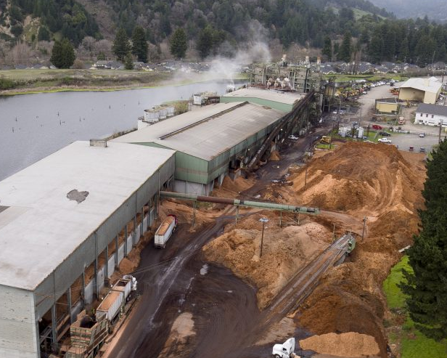

Table of Contents

Summary 3

Global Context for Biomass Power 3

Is Biomass Power a “Carbon Neutral” Climate Solution? 4

Air Quality Issues and Concerns 8

The California Context for Biomass Power 9

The Humboldt County Context for Biomass Power 10

Air Pollution Produced by Local Biomass Plants 13

Concerns About Forest Health and Sustainability 18

Support for and Opposition to Biomass-Generated Electricity 18

What Happens to Mill Residues if RCEA no Longer Buys Power from the Plants? 19

Other Options for Mill Waste Disposal 20

Potential Ways to Achieve Long-term Sequestration of Carbon in Local Mill Residues 22

The Future of RCEA’s Use of Biomass Power 27

References 28

Consultations and Expert Panelists 29

Summary
- Biomass helps to move away from the use of fossil fuels for generating electric power and can balance the supply from intermittent power from solar and wind generation. When more flexible grid solutions come about and storage facilities are added, this will become less important. Biomass is widely considered a climate change “bridge” solution.
- Biomass provides local electric power that is otherwise provided by the PG&E natural gas plant.
- Biomass is currently the only renewable local source of utility-scale electric generation.
- Biomass power emits air pollutants that are dangerous to human health when humans are exposed. Open burning emits more air pollutants and greenhouse gasses (GHGs), but human exposure to air pollutants in the field is usually comparatively small.
- Because wood products and mill residues are a part of the natural carbon cycle, biomass is often considered “carbon neutral.” However, because GHGs are emitted, carbon neutrality is difficult to establish.
- Burning biomass in a facility designed for power production entails efficient combustion and pollutant filtration systems. Most alternatives for mill residue (or biomass) disposal produce higher levels of GHG warming emissions or air pollutants than burning in a power-generating biomass plant.

Global Context for Biomass Power
Since the human discovery of how to start a fire, burning biomass has been the primary human energy source. Even today, more than half of the world’s population uses biomass as their primary energy source.
We have since transitioned modern society to burning fossil fuels for energy, not realizing that the emissions would disrupt the climate worldwide, with immense and growing adverse consequences.

The United Nations Intergovernmental Panel on Climate Change (UN IPCC) has recently concluded that to avoid severe climate consequences, greenhouse gas (GHG) emissions must be reduced dramatically as soon as possible.

Now we face a critical question: How do we move from powering our world with fossil fuels to using only the sun, the wind, moving water, and the heat of the earth’s crust?

We need “bridge solutions” in moving to new and necessary technologies, and biomass is considered a prime candidate worldwide. The potential to generate electricity and heat is obvious, but so are the drawbacks of air pollution, carbon emissions, and the concern for forest and agricultural management and impacts.

Lumber mills produce waste from product manufacturing, including sawdust, bark, cutoffs, wings, and other remnants. Some of this leftover material has economic value and is sold as chips for paper production, mulch, fiberboard manufacture, burnable pellets, and so on. To be utilized in these ways, the waste material must be of high quality. There must also be a current market demand, which can vary significantly over time.

What remains after these higher quality by-products are sold and transported away is a lower-quality material, woody biomass that has no current economic value. For decades, this material was disposed of by open burning. Among other impacts, black carbon (soot) and methane emissions from open burning are substantial, and especially adverse to atmospheric warming.

However, the same biomass can be burned to make steam that drives turbines generating electric power, with substantially fewer emissions. Biomass energy plants must meet strict regulatory requirements, including high efficiency burning and particulate filters on smokestacks.

While the use of biomass helps to move us away from the use of fossil fuels and helps provide continuity to the intermittent power from solar and wind generation, it also has drawbacks. As technologies improve with more flexible grid solutions, and as storage facilities are added, the need for biomass generation to bridge these gaps will diminish.

At present, biomass energy fuels about two percent of global electricity production, more than any other renewable source. In some countries—Sweden, Finland, and Latvia among them—bioenergy is 20 to 30 percent of the national generation mix, almost entirely provided by trees. Biomass use for electrical generation is also on the rise in China, India, Japan, South Korea, and Brazil. (Hawken, et al. 2017.)

Is Biomass Power a “Carbon Neutral” Climate Solution?
Climate change has primarily resulted from the extraction of fossil carbon from outside the natural carbon cycle and adding it to the atmosphere and oceans, resulting in significant and consequential radiative forcing and the rapid climate warming that we now observe. There is a global consensus that we must limit the further additions of fossil carbon to the atmosphere and do so as quickly as possible.

Biomass burns carbon-containing materials and thus emits greenhouse gasses (GHGs), but this carbon is considered to be “in the cycle” and does not contribute to increasing the total amount of carbon circulating within the earth’s biosphere. That is, the carbon in biomass would naturally be emitted as the plants die and decay, and after being emitted, is typically sequestered again through new biomass growth within years to decades.
Consideration and accounting for greenhouse gas emissions from biomass burning are nuanced.

The energy density of woody material is low relative to coal or natural gas. Thus, the CO₂ emissions per unit of useful energy are higher for woody biomass than from these other energy sources.

The CO₂ emissions per unit of energy generation are:
Natural gas: 118 lb. CO₂/MMBtu
Bituminous coal: 205 lb. CO₂/MMBtu
Wood: 213 lb. CO₂/MMBtu (bone dry)

Approximately 320,000 tons of CO₂ are emitted annually by the two local biomass plants.

Burning biomass produces carbon emissions. However, it is not adding fossil carbon that has been stored for eons far belowground, as is the case with fossil fuels. Biomass energy generation burns carbon that is in circulation, cycling from the atmosphere to plants and back again.
Does this carbon to the atmosphere count? Yes and no, depending on the timing of emissions and how we view the overall carbon balance and the continued extraction of fossil fuels.

The authors of Repower Humboldt pointed out several key issues that would need to be addressed before any expansion of biomass infrastructure. One of these issues was the assumption that biomass is “carbon neutral”:

“In general, biomass has been treated as a carbon-neutral resource as long as the harvest rate does not exceed the rate of new growth. However, this premise is currently being scrutinized and regulatory treatment of biomass could change. (...) These emissions can be assessed in a life-cycle analysis. This study treated biomass as a carbon-neutral resource. It is recommended that this assumption be further evaluated as a topic of future research.” (RePower 2013).
Biomass helps to move away from fossil fuels and helps balance the supply from intermittent power from solar and wind generation. When more flexible grid solutions come about and storage facilities are added, this will become less important.

Scientists tend to be split on whether biomass burning can be considered “carbon neutral.” The carbon loading of any biomass generation facility depends on its context: fuel source, transportation and handling costs, the degree of substitution for fossil fuels, and other factors, and differs from facility to facility.

Many scientists conclude that if trees grow back in a few decades and if harvest volume is equal to or greater than burned volume, the GHG inputs do not “count,” as they are re-sequestered, just as the carbon cycle has been operating for millions of years. That is, if burning biomass that is inside the natural carbon cycle substitutes for fossil fuels, many contend that this amount can be “subtracted”, creating a neutral or even carbon-negative result.

Others contend that a CO₂ molecule is the same and has the same radiative effect regardless of its source: and therefore, biomass burning does count as an adverse emission. In California and International carbon emissions accounting, some emissions from Land Use, Land-Use Change, and Forestry (LULUCF), which are inside the natural carbon cycle, are counted, while some are not, due to difficulties in measurement, such as for soil carbon.
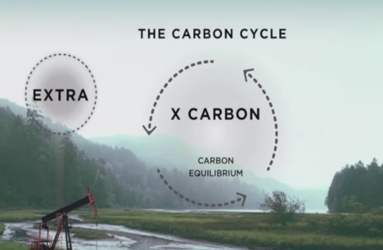 | 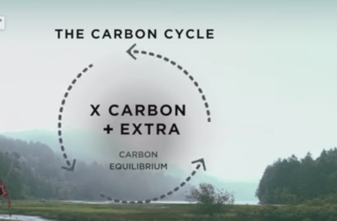
Figure 1: Billions of tons per year of non-circulating fossil carbon has been added to the carbon cycle. This is the primary driver of human-caused climate change.
According to Morris, 2008,
“ Carbon Neutral and Beyond: The greenhouse-gas emissions produced at biomass and biogas generating facilities comes from carbon that is already a part of the linked atmospheric – biospheric carbon cycle. This is in stark contrast to fossil fuel combustion, which removes carbon from permanent geologic storage, and adds it as net new carbon to the carbon already in the atmospheric – biospheric circulation system. Most people focus on this aspect of bioenergy production, and proclaim it to be “Carbon Neutral.” …. Biomass energy production can change the timing and relative mix (oxidized vs. reduced) of carbon forms emitted into the atmosphere associated with the disposal or disposition of the biomass resources. As a greenhouse-gas, reduced carbon (CH₄) is twenty-five times more potent than oxidized carbon (CO₂) on an instantaneous, per-carbon basis.”
How the GHG emissions are regarded in emissions accounting depends on many factors: changes in wildfire risk, frequency, extent, and severity; timing of emissions, the chemistry of environmental transformations; human interventions; applied logic and assumptions; assumed time periods of analysis; substitutions of biomass for fossil fuels; other avoided impacts, philosophy, and other factors.
The perplexities of the burning of biological carbon can be somewhat resolved by a thorough life-cycle analysis (LCA). Without a thorough life-cycle analysis, carbon neutrality cannot be claimed, quantified, or denied.

A formula used by US Forest Service economists for carbon neutrality is:
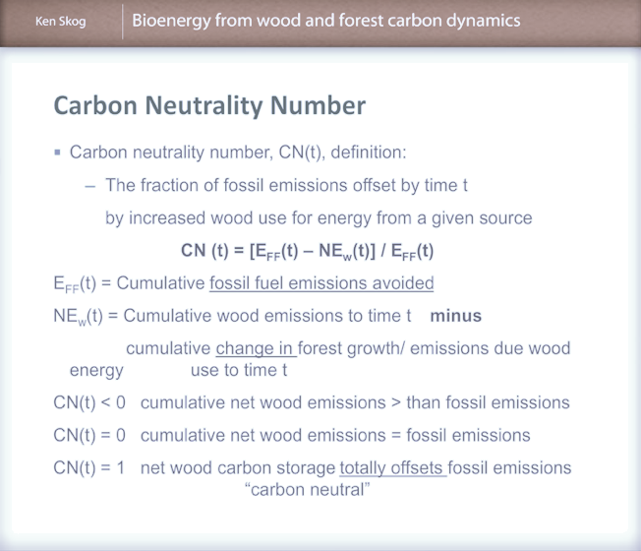
Figure 2: How the US Forest Service calculates a “carbon neutrality number”.
By US Forest Service economist Ken Skog. From: Swanston, Chris; Furniss, Michael J.; Schmitt, Kristen; Guntle, Jeffrey; Janowiak, Maria; Hines, Sarah, eds. 2012. Forest and grassland carbon in North America: A short course for land managers. Gen. Tech Rep. NRS- 93.
Considerable research effort is underway to more accurately assess the environmental and social impacts of biomass, including life-cycle assessment modeling and tool development at the Schatz Energy Research Center at Humboldt State University.
As assessed in Morris 2008, biomass burning changes the timing of GHG emissions:
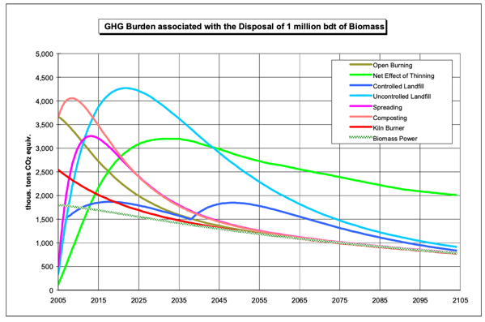
Figure 3: The curve for stack emissions from the biomass energy alternative is based on the immediate release of virtually all of the fuel-bound carbon as CO₂, followed by its gradual clearance from the atmosphere. The conversion of one million bdt of biomass leads to emissions of 1.75 million tons of biogenic CO₂ equivalents. Open burning and low-efficiency combustors (kiln boilers and fireplaces) also produce their emissions immediately, but their greenhouse-gas emissions are higher, in terms of tons of biogenic CO₂ equivalents, than those of the power alternative because of the release of black carbon and other products of incomplete combustion. (Morris, 2008).

Air Quality Issues and Concerns
There is growing worldwide recognition of the adverse health effects of smoke and other forms of air pollution that lead to a wide variety of serious human diseases and can shorten lifespans. Impacts can be especially severe for the young and infirm. Smoke from wildfires, open burning, biomass production, campfires, indoor cooking, and even candle burning can negatively impact human health. Recent large wildfires have exposed many city-dwellers to high levels of smoke and have sharpened awareness of this source of air pollution and its health consequences.
Smoke from burning wood emits several pollutants of concern, but by far the most serious is fine particulate matter – small particles that can pass through the lungs into the bloodstream. Small particles of 2.5 microns and below (PM_{2.5}) are of the most significant impact and concern. There is no safe level (No Effect Level or NOEL) recognized for exposure to particulate matter.
Other pollutants in smoke include nitrogen oxides, carbon monoxide, volatile hydrocarbon compounds, and secondary production of ground-level ozone.

The California Context for Biomass Power

In 2018, the California Department of Forestry and Fire Protection published California’s Forest Carbon Plan.
Some of the key findings of the report are:
- Reducing carbon losses from forests, particularly the extensive carbon losses that occur during and after extreme wildfires in forests and through uncharacteristic tree mortality is essential to meeting the state’s long-term climate goals. Fuel reduction in forests can increase the stability of the remaining and future stored carbon.
- The limited infrastructure capacity for forest management, wood processing, and biomass utilization, and the limited appropriately trained or licensed supporting workforce are significant impediments to forest restoration and ongoing forest management.
Near-term actions proposed by the State include:
- Expand wood products manufacturing in California and take actions to support market growth scaled to the longer-term projections of forest productivity and resource management needs.
- Continue public investment to build out the 50 megawatt (MW) of small scale (5MW or less sized facilities), wood-fired bioenergy facilities mandated through SB 1122 (Rubio, 2012).
- Maintain existing bioenergy capacity at a level necessary to utilize materials removed as part of forest restoration and to support long-lived storage of carbon in building materials.
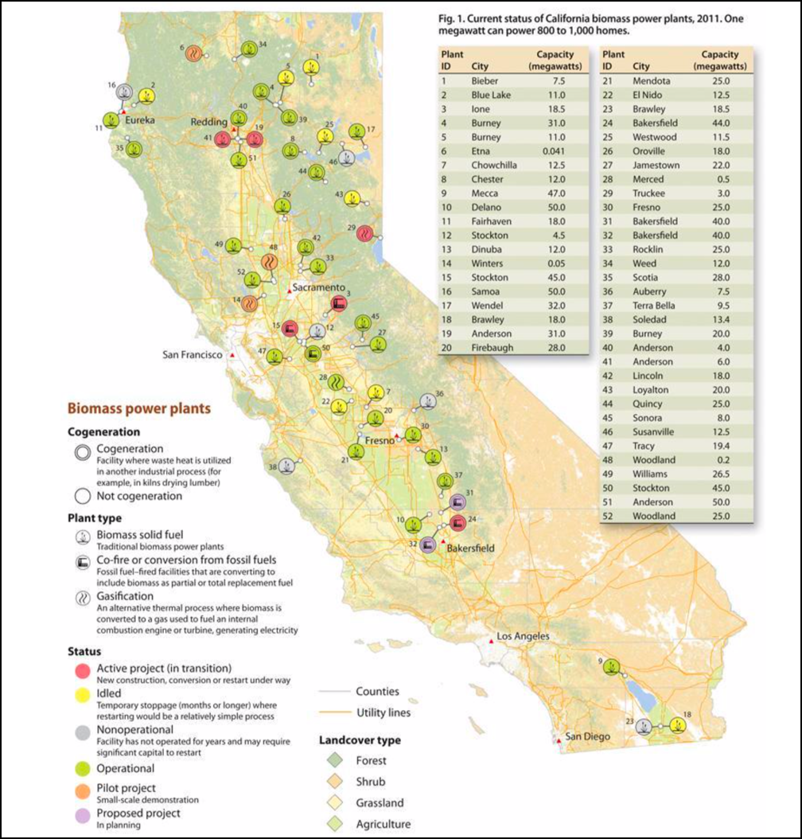
Figure 4: Current status of biomass power facilities in California. Map source: UC Division of Agriculture and Natural Resources. As the wood products and bioenergy landscapes in California are quite dynamic, some of the 2012 data presented here may no longer be accurate. The University of California maintains an up-to-date wood facility database at: https://ucanr.edu/sites/WoodyBiomass/Project/California_Biomass_Power_Plants/

The Humboldt County Context for Biomass Power
Biomass is presently the only local renewable energy source, with the minor exceptions of small solar installations and several small hydroelectric installations.
Humboldt County produces enough electricity for local consumption, using biomass and natural gas (RePower 2013). Additional generating capacity might increase soon if planned offshore wind power is installed and solar installations are built.
Biomass can generate continuous power output to the grid, contributing to meeting variable electricity demand and complementing the power available from intermittent solar and wind.
In Humboldt County, biomass electricity, primarily using mill residues, has been generating heat and electricity since the late 1980s. A local lumber manufacturing economy has been operating here for well over a century. Lumber mills generate remarkably large volumes of unusable wood materials, mostly sawdust, bark, and cutoffs. These have been disposed of in open burning until this was prohibited, and currently mainly in biomass generation plants.
The primary determinant of the quantity of mill residues used as fuel in California is the level of activity in the primary forest-products industry.
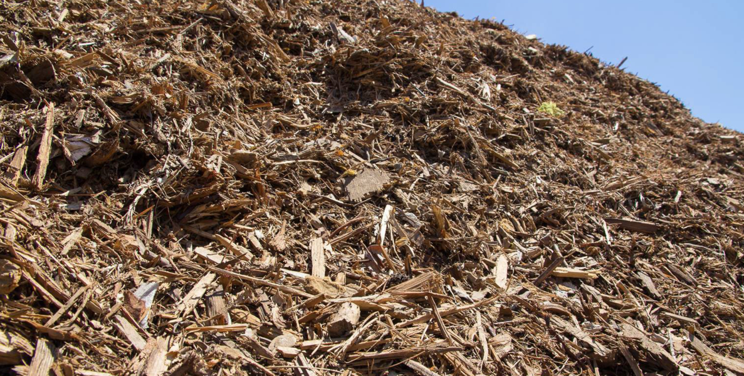
Figure 5: Unsaleable mill residues can look like this but vary in composition, sizes, and moisture content. A large percentage of this residue is in the form of sawdust.
Historically, mill waste that could not be sold as by-products was burned in “tipi burners.” During the height of timber harvest in Humboldt County, approximately 200 mills were operating – and each had a “tipi burner” that burned mill residues around the clock. During this era, a great deal of unfiltered smoke was emitted. Many of these burners can still be seen today at old mill sites.
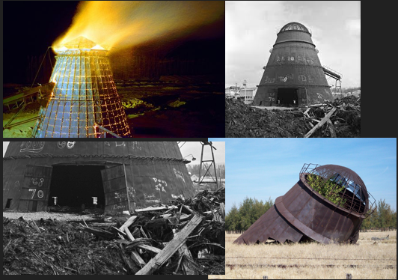
Figure 6: “Tipi burners” were common prior to stringent air pollution control regulations. Every mill had one, and they usually operated 24/7/365. The resulting air pollution was far worse than the comparatively efficient burning conditions with pollution controls in modern biomass plants.

Feed Material for the biomass plants
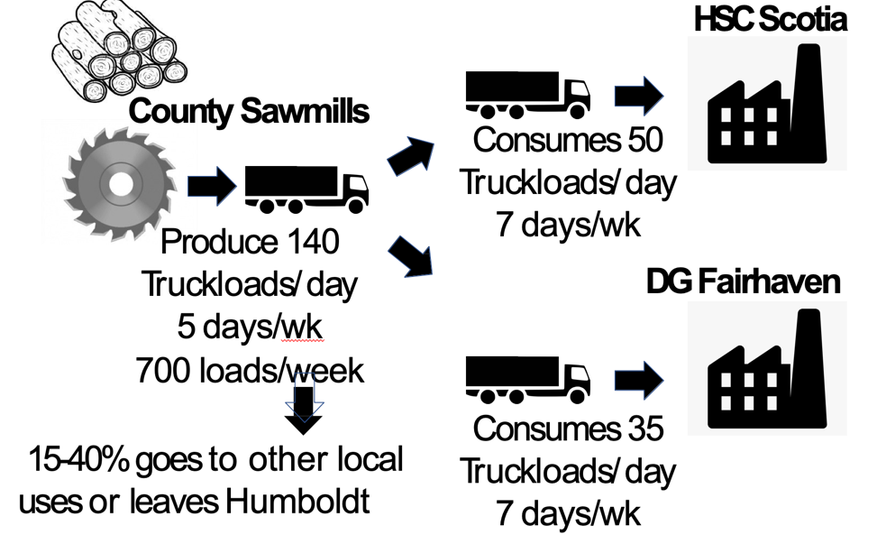
Figure 7: Typical currently-produced quantities of mill residue, based on queries to mill operators, via Yana Valochovic (personal communication). The feed material for the two contracted plants is residues from local lumber mills that are not otherwise used for salable by-products of lumber manufacture. Small amounts of logs from arborists and sanitation of logs killed by Sudden Oak Death are also included. Small quantities of waste logs from forest thinning on public land have been burned at DG Fairhaven in the past. Graphic by Richard Engel of RCEA.
Lumber mill operations have seen a steady decrease in the amount of waste per unit of lumber production via the use of computer analysis of logs for optimum lumber yield, low-kerf saws, and other technology.

Air Pollution Produced by Local Biomass Plants
Biomass power in RCEA’s mix is generated by burning mill waste, comprised of woody material from lumber mills. Burning wood creates smoke. Smoke includes air pollutants that adversely affect human health to those exposed.

 | PM_{2.5}  (lb./ton) | NOx  (lb./ton) | CO  (lb./ton) | VOC  (lb./ton) | CO₂  (lb./ton)
Industrial  (dry fuel) | 0.7-6.5 | 8.8 | 10.8 | 0.31 | 3120
Residential Stove | 6-23 | 2-14 | 46-160 | 10-44 | ~2800
Prescribed Burn | 12-34 | 6 | 167 | 19.0 | ~2700
Wildfire | ~30 | 4 | 140 | 12-24 | ~2600
Table 1: Emissions by type of combustion in pounds emitted per ton of woody biomass consumed. References: USEPA, AP12, Fifth Edition. McDonald et al. 2000, Environmental Science and Technology. USDA Forest Service, various reports

Air Emissions | Coal Fueled Boiler  (lb./MMBtu) | Biomass Fueled Boiler  (lb./MMBtu) | Natural Gas Boiler  (lb./MMBtu)
CO | 0.02-0.67 | 0.60 | 0.058
CO₂ fossil | 178-231 | 0 | 117.6
CO₂ non-fossil | 0 | 195.0 | 0
NOx | 0.27-1.15 | 0.22-0.49 | 0.031-0.27
SOx | 1.3 | 0.025 | 0.0005
VOC | 0.002-0.048 | 0.017 | 0.005
Methane | 0.002 | 0.021 | 0.002
Particulates | 0.37-2.4 | 0.05-0.56 | 0.007
Table 2: Average air quality impacts for boiler-spinner electricity generators

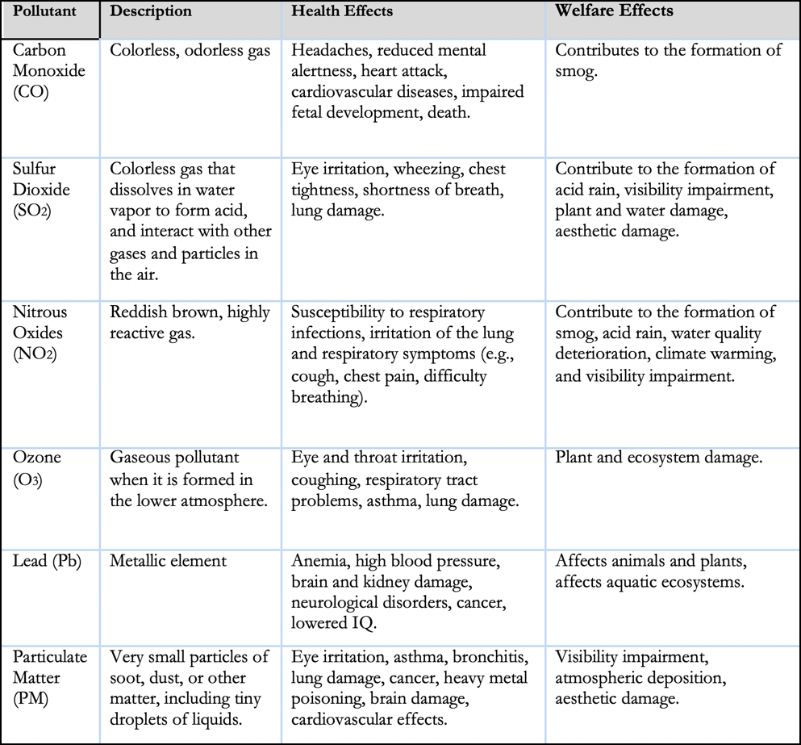
Table 3: Health and welfare effects of common pollutants (from: Furniss 2017)
Note: Both contracted local plants use grid power for start-up and ongoing operation, much of which is from fossil carbon (natural gas).

Permitted air pollutant discharges
HRC Scotia permitted discharge of PM (all sizes) = 0.04 lbs./MMBtu
DG Fairhaven permitted discharge of PM (all sizes) = 0.10 lbs./MMBtu
Blue Lake permitted discharge of PM (all sizes) = 0.04 lbs./MMBtu

Table 4: Reported greenhouse gas and air pollutant emissions for 2016. Data from California Environmental Protection Agency Air Resources CARB Pollution Mapping Tool. Accessed 11/18/2019
The current annual fine particle standard has been revised from the current level of 15.0 micrograms per cubic meter (µg/m3) to 12.0 µg/m³. An area will meet the standard if the three-year average of its annual average PM_{2.5} concentration (at each monitoring site in the area) is less than or equal to 12.0 µg/m3
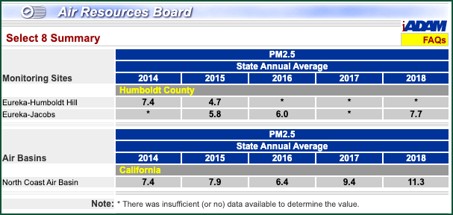
Table 5: Comparison of Eureka-Humboldt PM2.5 averages for 2014 to 2018 with statewide values.
The annual standard is 12.0 µg/m³. Last five years: 5.8 – 7.7 µg/m³.

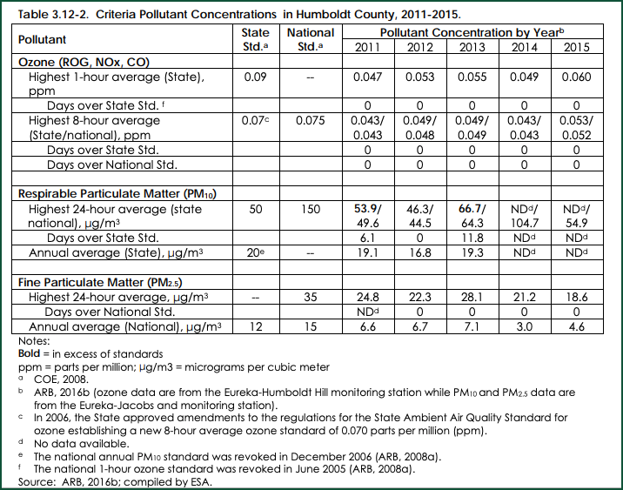
Table 6: A sampling of criteria pollutant concentrations for Humboldt County and state and national standards. (USEPA 2012 The National Ambient Air Quality Standards for Particle Pollution Revised Air Quality Standards for Particle Pollution and Updates to The Air Quality Index (AQI))

Air quality and Ambient Air Monitoring in Humboldt
Air quality is continuously monitored in Eureka and is usually in the “good” category, considered “healthy” and “attaining” USEPA air quality standards, except sometimes for particulate matter. Humboldt County is a considered a “Non-Attainment” area for PM₁₀ particulate air pollution.
No official monitoring of ambient air quality is done in Fairhaven or Scotia, where exposure to biomass emissions would be expected to be the greatest.
The North Coast United Air Quality Management District (NCUAQMD) has issued permits to the three biomass plants in Humboldt County. Emissions are monitored at the stack of the 2 operating plants in each location. However, no official monitoring of ambient air quality is done in Eureka, Fairhaven, Scotia, or Blue Lake where exposure to biomass emissions would be expected to be the greatest.

Site emissions alone do not accurately describe the public health hazard; measured human exposure to emitted pollutants is necessary to understand public health impacts. Unfortunately, this data is not currently available. The District has stated that it has conducted exposure modeling in formulating the permits, but that this information is not publicly available. Currently, ongoing exposure modeling and monitoring are not being conducted.

In the absence of exposure modeling and monitoring, public health risks cannot be quantified or described. Scotia, DG Fairhaven, and Blue Lake plants are proximate to population centers. The DG Fairhaven plant is across a typically windy Humboldt Bay from the Eureka population but is proximate to the community of Fairhaven.

Biomass Plant Air Quality Controls
The emission control tools utilized at the two RCEA-contracted plants include (from their permits):
DG Fairhaven
- Mechanical Multicyclone Collector
- Electrostatic Precipitator
- Forced Overfire Air System
HRC Scotia
- Particulate matter is controlled with multiple cyclones followed by an electrostatic precipitator manufactured by General Electric Co. The unit has three separate transformer/rectifier fields and a collection plate area of 42,120 sq.ft. Two of the fields are rated at 50 KVA and one at 35 KVA. A forced overtire air system is utilized to help control gaseous emissions.

Concerns About Forest Health and Sustainability
The source material for biomass burning is a central issue in most biomass power locations. That is, concerns are frequently raised about unsustainable pressure to harvest forests and also about the utilization of agricultural lands for products other than food production.
These are not currently predominant concerns in Humboldt, as the feed material is primarily mill waste only. The minor exceptions are that the plants accept arborist waste and sanitation logs that must be burned, such as tanoak infected with Sudden Oak Death disease.
While current biomass plant material requirements are currently satisfied by mill residues, some additional capacity exists at HRC and more could be added, and new plants could be built. This could lead to markets diverting more mill waste than currently utilized, and forest management activities could produce source material for the plants.
Additionally, some forestry officials in California are working to increase thinning and controlled burning to reduce wildfire hazards and improve forest health. Pre-commercial thinning for fuel reduction is expected to increase markedly throughout California forests in the near future. Considerable funding is becoming available for this work. Large amounts of small logs and slash will be generated.
However, the economics of transport primarily keeps this material in the woods; it is simply not worth the transportation costs to bring it to the mills or the biomass plants. A haul of more than ~50 miles is considered to be economically infeasible as the transportation costs would exceed the market value of the material. The small logs and slash must therefore be treated in the woods to reduce fire hazards and enable regeneration.
There are several active research and development projects, including a local effort to evaluate various means of on-site processing of fuel treatment thinning and the associated large volumes of slash. These methods include more efficient burning processes, wood-energy concentration to extend the economically feasible transportation distance, and production of biochar.
Because sawlogs are always far more valuable for lumber manufacturing than for burning in biomass plants, logging to feed biomass plants is not likely to occur.

Support for and Opposition to Biomass-Generated Electricity
Support:
Some groups have publicly supported this technology, including forestry and timber manufacturing professionals, primarily because it supports their industry. Climate scientists and specialists are also generally in favor of biomass as a bridge solution, but with caveats. California Air Pollution Control Officers Association (CAPCOA) has also issued a written statement in favor of biomass as a way to limit air pollution from other methods of waste incineration or adding to it to landfills.
Opposition:
Currently, public opposition to biomass burning is substantial. Vocal opponents come to the RCEA Community Advisory Committee and California Air Resources Board meetings and express opposition and concerns, primarily about air pollution, greenhouse gas emissions, and forest management.
Additionally, many medical professionals, as represented by several professional medical societies, and two local physicians, have strong concerns and opposition due to particulate air pollution and greenhouse gas emissions. See: (https://www.epa.gov/sites/production/files/2014-05/documents/huff-particle.pdf) for summary of particulate pollution and health.

Opponents frequently note that biomass cannot be considered “clean” because it emits both air pollutants and greenhouse gases. There is no broadly accepted definition of “clean” energy. In the context of energy and climate in California, “clean” means “non-fossil and non-nuclear” and not that there is no associated pollution.
Nationally, health organizations that have publicly opposed biomass power include: the American Academy of Pediatrics, American Lung Association, American Public Health Association, Asthma and Allergy Foundation of America, National Association of County & City Health Officials, National Environmental Health Association, Trust for America's Health, Children's Environmental Health Network and Physicians.
Local environmental organizations that have weighed in on these issues include 350-Humboldt and the Environmental Protection Information Center (EPIC), and both are “neutral” at the time of writing.
Exceptions exist within each of these groups and gaining the full support of the community is not likely or possible.

What Happens to Mill Residues if RCEA no Longer Buys Power from the Plants?
As noted, a large volume of residue is generated at local mills. If biomass is not burned for electric generation locally, options for disposal include:
- HRC uses biomass power for mill operations and heat from the plants for lumber drying, and so would continue to run at some level even if there were no electricity buyers.
- Material could be transported out of the county to other biomass plants or to landfills. For example, material could be transported to Anderson, California (or other more distant plants) for burning in the Wheelabrator biomass plant there, which is about 300 miles round trip.
- Because open burning is unlikely to be permitted locally due to air pollution regulations, the residue could be hauled to an acceptable open burning location.
- Plants sell electricity to other buyers, such as a community choice energy program serving jurisdictions outside of Humboldt County, as many municipalities have a mandate for renewable energy and biomass power “counts” as a renewable source.
- A final option would be closing the mills and sending logs out of the County for milling, likely to Oregon. Prices for local logs would decrease substantially. This would have the unfortunate effect of making restoration forestry, road maintenance, and wildfire-resilience thinning, all of which are expensive, less feasible and less likely to be practiced.
None of these options eliminates GHG emissions, and most would increase both air pollution and GHG emissions. Landfilling of mill waste could decrease air pollution but substantially increase GHG gas emissions, including methane. However, current severe systemic societal waste disposal challenges would worsen, and landfills might not accept such large quantities of organic wastes.

Other Options for Mill Waste Disposal

Discovering or developing additional products and markets for the residues.
Mill operators are always looking for new and re-emerging by-product markets for mill residues. The potential depends on the existence of markets, levels of demand, manufacturing technologies and distance to markets. The quality of the unused material is often substandard for any commercial uses and sales: it is too variable in size, often has rock and dirt contamination, and has variable moisture content. Unless the provenance of the material in the piles is verifiably known, insect and pathogen non-presence cannot be assured.
Residues are currently and potentially sold as “by-products” for:
- Chips for paper manufacture, mostly to Asia, but also the PNW states. Paper manufacture requires large, clean chips, and there is currently a market for these over the Fairhaven Loading Dock.
- Small amounts of residues are sold for compost-making, landscaping, animal bedding, playground mulch, and so on.
- Burnable wood pellets are commonly produced and sold from Eastern USA forests for sale to the EU, Japan, and other places to substitute for coal burning, as a climate mitigation. There might be a potential market for local burnable pellets, particularly for industrial use where feed material quality and polish are less important than for consumer-grade pellets.

A challenge to selling by-products is that interstate and international quarantines exist to prevent the introduction of pathogens and invasive insects. This is a barrier to export for some types of sales.

Emerging technologies include: gasification, torrefaction, biochar, and others are in active research and development locally and elsewhere.
Gasification converts woody materials into gasses by reacting the material at high temperatures (typically >700 °C), with little oxygen. The product is wood-gas fuel that can be burned as fuel in furnaces, stoves, and vehicles in place of gasoline, diesel, or other fuels. Biochar is a byproduct.
Gasification is relatively expensive and energy-intensive. The moisture content of the feedstock must be carefully controlled. Some of the sawmill residues could be diverted to a gasification plant, but it would require a significant capital investment and tight controls on the quality of the feedstock. The material would be burned with the associated carbon emissions. Gasification technology is not currently at a feasible scale to process the amount of available local sawmill residues.
Torrefaction increases the energy density of wood and involves the heating of biomass in the absence of oxygen to a temperature of typically 200 to 400°C. The weight loss is about 30%, but the energy loss is ~10%. The main product is the solid, torrefied biomass, either as torrefied wood material or briquettes. During the torrefaction process, combustible gas is produced that provides heat to drive the process. (Biomass Technology Group, Accessed 11/11/19)
Torrefaction produces material to burn for heat or electrical generation, not for carbon sequestration.
A discussion of biochar may be found on Page 24.

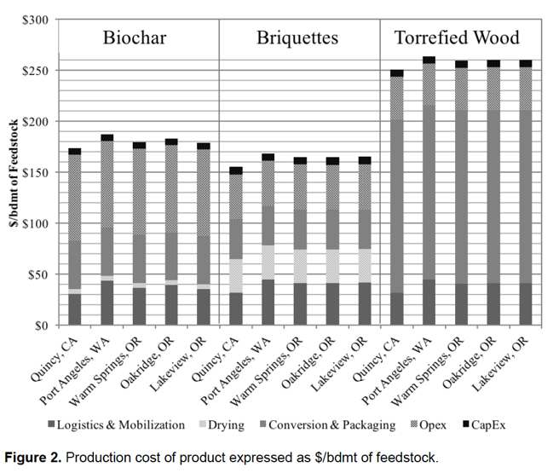
Figure 8: Cost comparison for production of biochar, torrefied briquettes, and torrefied wood. From: Waste to Wisdom. 2018. Utilizing forest residues for the production of bioenergy and bio-based products.

Potential Ways to Achieve Long-term Sequestration of Carbon in Local Mill Residues
A substantial opportunity exists for carbon sequestration of the embodied carbon in mill residues if a method to do this can be developed at the required scale and is economic against other options for disposal. To be meaningful for climate change, carbon must be sequestered for a century or more.

Manufactured products
Manufactured building materials can be an effective means of sequestering the carbon in mill residues, but at present, requires high-quality starting material. Sawdust, mill ends, and cutoffs are generally not suitable. That is, some mill waste can be manufactured into long-lived building materials, but a substantial residue of unsuited materials will always remain.

Composting
Composting of the non-salable residues is a common suggested method for mill waste disposal and creating a valuable product.
Sawdust is commonly added to biosolids (sewage sludge, kitchen waste, or both) in making compost to add carbon-rich materials. Compost manufacture and biosolids disposal is the objective of these efforts, not mill residue disposal, and the operational scales are tiny when compared to the volume of local mill residue. Demand for compost that contains biosolids is limited by societal acceptance.

Advantages of composting
Compost improves soil fertility, and increased soil fertility furthers soil carbon sequestration and supports plant growth.
Compost can substitute for synthetic nitrogen fertilizer, which is a significant source of NOx emissions. NOx is a powerful greenhouse gas and air pollutant and persists longer in the atmosphere than CO₂ or other GHGs.
A small proportion of compost can form long-term soil humus, especially when lignin-rich wood is the source material.

Compost creation at the needed scale entails substantial challenges:
- Most of the carbon in compost returns to the atmosphere in years or decades as compost decomposes. A small amount of compost might remain for climate-meaningful periods (100+ years), but the large majority does not remain for nearly that long.
- Local mill waste comprises a large volume of material. The scale is significant and composting this amount of wood waste is unprecedented.
- Composting would require substantial energy inputs to process and transport the resulting compost.
- Processing and storing a large amount of compost presents fire hazards because the decomposition process generates and accumulates heat and compost fires are common. (The recent Burris wildfire incident in Lake County was ignited by a compost pile.)
- For composting to occur, Nitrogen-rich material must be added to support decomposition. Sawdust is typically 325:1 carbon to nitrogen (C:N), while the rapid composting that is required to destroy pathogens and create high-quality compost needs a C:N of 25-30:1. Sewage, kitchen waste, or green waste could provide the needed N, but concerns about transport, mixing, sanitation, weeds, pathogens, costs, and public nuisance would be present in any such operations.
- There are concerns about invasive plants and pathogens surviving the composting process and being introduced to fields where compost is applied. Most applications would require certified weed- and pathogen-free compost, and this can be difficult to achieve and ensure.
- The composting process releases methane and N₂O, especially powerful greenhouse gasses.
- There are limited local markets. An existing local green waste composting facility is currently producing more than the market demand. Non-local markets could likely be developed.

Biochar as a means to sequester carbon in woody wastes
Producing biochar currently offers the most technically feasible option for sequestering the carbon in mill residues.
Biochar is a charcoal-type substance, produced by burning biomass material in a controlled process called pyrolysis. During pyrolysis, biomass is burned in a container with little or no oxygen. During the pyrolysis process, the organic material is converted into biochar and wood gas. Wood gas can be used as a fuel and can help to power the pyrolysis process.
Biochar a highly stable form of carbon that does not decompose or return carbon to the atmosphere. Biochar converts the carbon in biomass to a stable, long-term material. However, only roughly half of the carbon in the feed material is sequestered. The pyrolysis process produces GHG emissions and air pollutants, though much less burning raw woody material for biomass electricity generation.

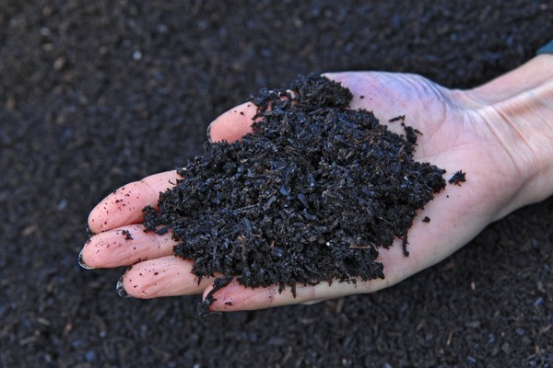
Figure 9: Biochar is black, highly porous, lightweight, fine-grained, and has a vast surface area. Approximately 70 percent of its composition is carbon. The remaining material consists of nitrogen, oxygen and hydrogen and other elements. Biochar’s chemical composition varies depending on the feedstocks used to make it and methods used in pyrolysis.
Biochar is a highly beneficial soil amendment, increasing water- and nutrient-holding capacity, enhancing soil biology, decreasing N₂O emissions from soils, and enhancing the sequestration of recalcitrant carbon in soil through increased soil fertility and plant growth. (Severy et. al. 2018). Recent research points to electron channels in biochar that enhance soil microbial ecology (Sun et al. 2019).
Incorporating biochar into soils is a sound and tested method of storing carbon for long periods.
U.S. Forest Service research is demonstrating the benefits of making and using biochar. https://www.fs.fed.us/blogs/promise-biochar-forests-grasslands-and-farms
The potential to sequester carbon using biochar is well-recognized and the methodology and production equipment are available.
However, using the large quantities of local mill residue to make, market, and distribute biochar requires further research and development to establish the economic, sociologic, market, and logistic costs and benefits.
A large-scale local pilot project to learn how this could be done would be a useful contribution to current limited regional information. A public-private partnership might be the best way to accomplish this.
A new report has just been published by the Sierra Club that examines the context and some of the details involved in alternatives to burning woody material from forestry operations. (Sierra Club, 2019).

Waste Option | Potential GHG impacts | Time frame for sequestration | Other  impacts/considerations
Landfilling | Potential for  substantial amounts of methane to be released, particularly if gases are not collected | Decades | California law may make it difficult to landfill organics.  Methane production increases warming potential over alternatives. Less air pollutants.
Composting | 5-20% of carbon sequestered but for short time periods; potential to release substantial amounts of methane | 10-20 years | Expensive and complex at scale. Needs addition of N-rich material. Energy required for handling and processing. Benefits to soil. Potential multiplier effect as increased soil fertility increases plant growth and recalcitrant humus formation. Substitutes for N fertilizer reducing associate N₂0 emissions.
Raw biomass incineration | Most carbon converted to CO₂ | Essentially instantaneous | Human health impacts. Not permitted where human exposure to air pollutants is high. Higher GHG effects
Gasification | Similar GHG emissions as raw biomass incineration | Essentially instantaneous | Typically more efficient than raw biomass incineration; may have lower air quality impacts.
Biochar production | ~50-80% of carbon sequestered | 100-1000 years, | Expensive to scale; particulates and GHGs are released during production. Benefits to soil. Multiplier effect increasing plant growth and recalcitrant humus formation.
Production of charcoal or wood pellets for fuel | Similar GHG production as raw biomass generation. Depends on burning technology and transportation costs | No sequestration | There is some demand for wood pellets and charcoal products to substitute for the use coal in electricity production in Asia.
Sale and reuse, durable products, including mass timber products | Most or all carbon in waste sequestered (theoretically). Can substitute for concrete and steel, with large avoided emissions | Potentially, 100+ years | Requires adequate base material, sawdust and end pieces are not suited for present technology. Potential environmental, health and climate impacts from glues.
Table 7: Options for mill residue disposal. Adapted and modified from Gurin et al., 2018

The Future of RCEA’s Use of Biomass Power
Adaptive management planning is always a sound strategy. Scenario-based planning can accommodate the uncertainties of future energy supplies, technology, climate policy, and economics.

Several considerations are paramount:
The future holds some crucial unknowns and unknowables: Technology developments, availability and price of energy sources, electric grid upgrades, markets for various mill residues, climate policies for mitigation including sequestration incentives (such as offsets for sequestering mill residues), and future air quality regulation, to name a few.
Biomass power plants need some assurance of being able to sell power to justify upgrades to increase efficiency and reduce air pollutants. These upgrades are expensive and often involve shutdowns for installation.
Scenarios can be created to evaluate potential futures and inform future decisions. For example, scenarios could be built for solar and wind power availability and prices into the future, increased grid flexibility for dispatchable power, and how these compare to a likely fixed price of biomass power. If prices, availability, and dispatchability cross a threshold, biomass power might be abandoned in one scenario and continued in another.
It is reasonable to expect that the cost to produce biomass power will fluctuate with fossil fuel prices, but not otherwise change much in the next decade, while the costs of wind and solar are likely to continue to decline sharply. At what point is the differential determinative as to continuing to use biomass power? Future decisions to use biomass for power might turn on economics and the need for baseline power.

Leveraging Incentives for Better Air Pollution Control Technologies
Ideally, the biomass plants would use the Best Available Control Technology (BACT) to limit air pollution effects. This is not currently the case as the plants were built and permitted long ago. Implementing state-of-the-art control of air pollution is a reasonable goal for any power purchased by RCEA, as the emissions are directly connected to the purchases, and public health is an agency responsibility. RCEA could considering adding financial incentives and contract language to provide air quality protection beyond what the State requires, and be able to cancel contracts if emissions performance is substandard.

References
Furniss, M.J. 2017. Methodologies for Determining Carrying Capacity of Environmental Elements in Viet Nam for the Environmental Planning Process: With a focus on air and water pollution. Institute of Strategy and Policy on Natural Resources and Environment (ISPONRE) and Ministry of Natural Resources and Environment (MONRE). UNDP-Vietnam
Gurin, Fiske, and Gaiera. 2018. Biomass Energy in Humboldt County. 350 Humboldt
Han, Han-Sup; Jacobson, Arne; Bilek, E.M. (Ted); Sessions, John. 2018. Waste to wisdom: utilizing forest residues for the production of bioenergy and bio-based products. Applied Engineering in Agriculture. 34(1): 5-10.
Hawken, P. (Ed.). (2017). Drawdown: The most comprehensive plan ever proposed to reverse global warming. Penguin.
RePower Humboldt. A Strategic Plan for Renewable Energy. Security and Prosperity. March 2013. RePower Humboldt.
Severy, M. A., Carter, D. J., Palmer, K. D., Eggink, A. J., Chamberlin, C. E., & Jacobson, A. E. (2018). Performance and emissions control of commercial-scale biochar production unit. Appl. Eng. Agric, 34(1), 73-84.
Sierra Club, 2019. Moving beyond incineration: Putting residues from California forest management and restoration to good use. 37 p.
Sun, T., Levin, B., Guzman, J. et al. Rapid electron transfer by the carbon matrix in natural pyrogenic carbon. Nat Commun 8, 14873 (2017) doi:10.1038/ncomms14873
Swanston, Chris; Furniss, Michael J.; Schmitt, Kristen; Guntle, Jeffrey; Janowiak, Maria; Hines, Sarah, eds. 2012. Forest and grassland carbon in North America: A short course for land managers. Gen. Tech Rep. NRS- 93.
USEPA, 2012. Overview of Particle Air Pollution (PM_{2.5} and PM₁₀). (https://www.epa.gov/sites/production/files/2014-05/documents/huff-particle.pdf,
Gathered research materials (not an RCEA site): https://sites.google.com/view/biomass-info/home

Consultations and Expert Panelists

September 13th expert panel
Mark Andre, City of Arcata
Richard Engel, RCEA
Kevin Fingerman, HSU Environmental Science
Colin Fiske, 350 Humboldt
Carrise Geronimo, Schatz Energy Research Center
Katy Gurin, 350 Humboldt
Julia Levin, Bioenergy Association of California
Melanie McCavour, Hunboldt State University, Dept. of Environmental Science & Management. Humboldt County Planning Commission
Timothy Metz, Restoration Forestry, Inc.
Bob Moreno, DG Fairhaven Power, LLC
Michael Richardson, Humboldt Sawmill Company
Wendy Ring, Independent physician
Adam Steinbuck, Humboldt Redwood Company
Andrea Tuttle, Freelance forest carbon expert
Yana Valachovic, UC Cooperative Extension
Michael Winkler, City Council of Arcata, RCEA Board of Directors
Sheri Woo, HBMWD, RCEA Board of Directors

October 18th panel
Richard Engel, RCEA
Kevin Fingerman, HSU
Angie Lottes, California Department of Forestry and Fire Protection
Wendy Ring, Freelance physician
Adam Steinbuck , HRC Scotia
Yana Valachovic, UC Extension
Jason Wilson, NCUAQMD
Michael Furniss, Consultant to RCEA - Moderator

Individual Consultations
Juliet Bohn, Clean Energy and Waste Utilization Strategist, Juliette P. Bohn Consulting
Jason Davis, Deputy Air Pollution Control Officer, North Coast Unified Air Quality Management District
Richard Engel, Director, Power Resources, Redwood Coast Energy Authority
Kevin Fingerman, Assistant Professor, Energy & the Environment, HSU
Jana Ganion, Director of Sustainability and Government Affairs, Blue Lake Rancheria
Larry Goldberg, Vice Chair RCEA CAC and 350 Humboldt Steering Committee
Katy Gurin, Hydraulic Engineer, AECOM
Arne Jacobson. Director of the Schatz Energy Research Center (SERC) and Professor of Environmental Resources Engineering Professor, Humboldt State University
Angie Lottes, Assistant Deputy Director for Climate & Energy, California Department of Forestry and Fire Protection
Matthew Marshall, Executive Director, RCEA
Melanie McCavour, Hunboldt State University, Dept. of Environmental Science & Management. Humboldt County Planning Commissioner
Bob Moreno, Manager, DG Fairhaven Power, LLC
Wendy Ring, Physician, Climate/Health activist, producer of Cool Solutions Radio Show
Gary Rynearson, Manager, Forest Policy and Sustainability. Green Diamond Resource Company
Adam Steinbuck, Director, Fiber and Freight, Humboldt Redwoods Company, LLC
Nancy Stephenson, Community Strategies Manager, RCEA
Andrea Tuttle, former Director of the California Dept. of Forestry and Fire Protection (CDF). Freelance forest carbon expert
Yana Valachovic, County Director and Forest Advisor, Humboldt County UC Extension
Tom Wheeler, Executive Director, Environmental Protection Information Center
Brian Wilson, Air Pollution Control Officer, North Coast Unified Air Quality Management District
Michael Winkler, Mayor, City of Arcata, RCEA Board of Directors
Sheri Woo, Environmental Engineer, SHN Consulting Engineers and Geologists. Humboldt Municipal Water District Board of Directors, RCEA Board of Directors

