CITIZEN SOURCING
Response Form

For Community Choice Energy Programs

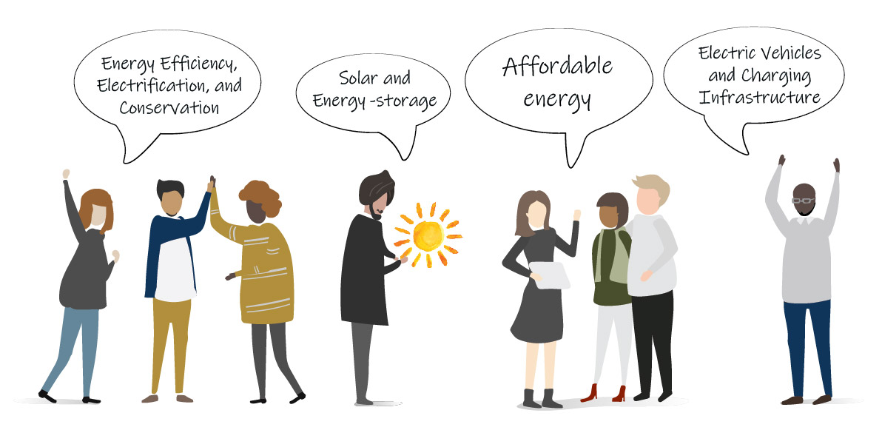

February 4, 2019

PROPOSALS DUE:
March 14 for first review
October 31 subsequent annual reviews

633 3rd Street, Eureka, CA 95501 | (707) 269-1700 ext: 352
Proposals should be limited to two pages, addressing all required sections as noted below, plus a maximum of three pages of supplementary material. Page count excludes your cover page. Your idea should be completely self-contained, with the intent that a reviewer can read and understand it in 15 minutes or less. As appropriate, RCEA will request additional information to more fully evaluate an idea.
- Cover Page
Include no less than the following:
- RCEA reference number CS 19-001
- Clearly indicate company/individual name, address, and primary contact’s information (mailing address, phone numbers and email)
Delete Instruction Box Prior Submitting to RCEA

Program Description:
Briefly describe the program concept and vision, how you would define success, the amount of time and estimated budget needed to fully realize that vision.
If applicable, please document any match dollars that could be leveraged.
Delete Instruction Box Prior Submitting to RCEA

Problem Statement:
Please discuss why this program is needed in our community and how it will address that need.
Delete Instruction Box Prior Submitting to RCEA

Program Scope:
Describe the scope of the program. Please also include customer sector (e.g. residential, California Alternate Rates for Energy Program (CARE)-eligible, business), target participants and/or beneficiaries.
Delete Instruction Box Prior Submitting to RCEA

