Electric Vehicle Incentives
For many consumers, the upfront cost of electric vehicles, along with necessary charging equipment, keeps EVs out of reach. Fortunately, there are a number of incentives available to make the switch to electric much less shocking.
Federal Tax Credit  Qualifications:  battery ≥ 5kW | The federal government wants to see you in an EV. They offer a tax credit of $2,500 for the purchase of a new electric vehicle (EV), with an additional $417 for every kilowatt hour of juice the vehicle’s battery has above the 5 kilowatt hour minimum. This adds up quickly in most new EVs, with the credit capped at $7,500. Visit irs.gov for more info.
CVRP Rebate  Qualifications:  California Resident  Income under $250k | Unlike the Fed’s tax credit, which is applied to taxes owed at the end of the year, the Clean Vehicle Rebate Project’s $2,500 rebate provides instant savings. The process is simple: purchase a new BEV ($2,500 rebate) or a PHEV ($1,500 rebate). Residents making under $35k are eligible for an additional $1,500. Fill out an online form and receive a check in the mail. Head to cleanvehiclerebate.org for more details and compare qualifying vehicles.
California Vehicle Assistance Program | Invest in a standard hybrid, EV, or PHEV and receive a $2,500 or $5,000 grant right away! Released August 2018, this new incentive program offers a grant and optional low interest loan to lower-income single and multi-family households. Visit cleanvehiclegrants.org to see if you are eligible to receive this awesome deal.
PG&E Rebate | Electric utilities also want to assist new BEV/PHEV drivers with a $800 rebate! PG&E provides this rebate to CCA and non-CCA customers alike. To apply, please visit pge.com. This rebate will be available beginning in January 2019.
Electricity Rates | When it’s finally time to plug in, EV owners can often take advantage of lower rates for electricity. For CCA customers, cheaper night time charging is available through the special EV-A rate. Compare different rate plans at redwoodenergy.org. To determine potential cost savings and to change your rate, you will need to contact PG&E.
HOV Lane Access | EV owners are eligible for a limited number of “Clean Air Vehicle” stickers which grant access to High Occupancy Vehicle (HOV) lanes and provide discounts for tolls in High Occupancy Toll (HOT) lanes to qualified vehicles. Visit DMV.ca.gov for more details.
Equipment Incentive | Most EV owners agree a level 2 charger in the garage is essential, and businesses can increase foot traffic by providing charging for customers. Prices range from $400 to $5000, plus installation costs anywhere from $200 to several thousand dollars. California offers a variety of equipment incentives that are listed here. The California Electric Vehicle Incentive Project will be rolling-out in Humboldt County in April 2019, and will provide additional discounts.
Insurance Discount | Even after driving off the lot, the saving continues. Farmers Insurance offers a 10% discount to drivers of Alternative Fuel Vehicles (AFVs). Guess what? That new battery powered car is pretty alternative. See details at farmers.com/california.
Sample Costs after Incentives (2018 models)
 | 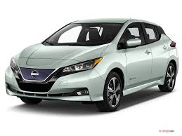  Nissan Leaf | 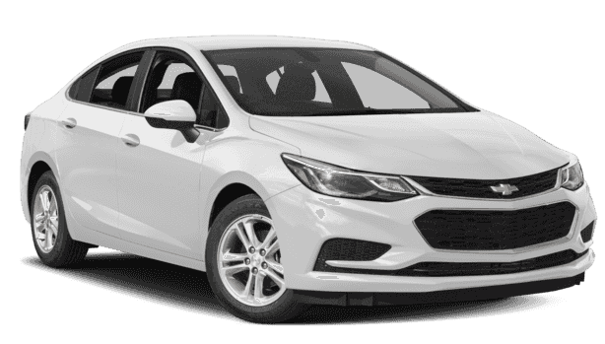  Chevy Volt | 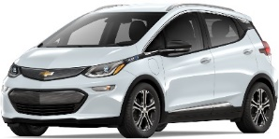  Chevy Bolt | 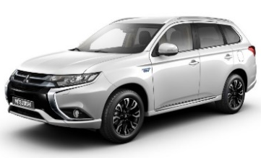  Mitsubishi Outlander
MSRP | $29,990 | $33,220 | $36,620 | $34,595
Federal Tax Credit | -$7,500 | -$7,500 | -$7,500 | -$4,007
CA CVRP Rebate | -$2,500 | -$1,500 | -$2,500 | -$1,500
Cost | $19,990 | $24,220 | $26,620 | $29,033
All Electric Range | 151 mi.  BEV | 53 mi. all-electric/420 mi. total  PHEV | 238 mi.  BEV | 22 mi. all-electric/400 mi. total  PHEV

Assumes that funding remains. After 200,000 vehicles are sold by a manufacturer, credits are reduced.
Assumes Individual income is between $35,000 and $250,000.
California Vehicle Assistance Program $5,000 grant is not included.
Battery electric vehicles (BEVs) rely exclusively on a battery, while plug-in hybrid electric vehicles (PHEVs) incorporate an internal combustion engine (ICE). Range calculations for PHEVs reflect the combined battery/electric range and ICE range.

